2021 Premier Sports Village Baseball
Central States World Series
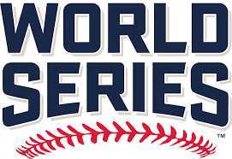
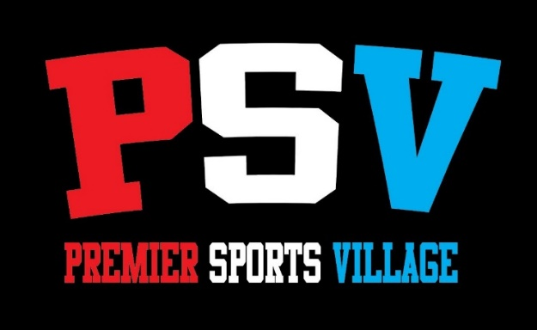
July 8th – 11th

Format: 32 Team - Bracket play with winners advancing in the winner’s bracket and the losers advancing in the consolation bracket. Three Game guarantee
Level: Open Tournament
Cost: $450
Location: Premier Sports Village 14402 Harlan Lewis Rd. Bellevue NE 68005
Dates: Thursday July 8th – Sunday July 11th
Game Guarantee: Four Game Guarantee
- $200 refund if only two games played
- $300 refund if only one game played
- $350 refund if no games played
Registration Information:
Team Name:
Head Coaches Name:
Coaches E-Mail:
Coaches Phone Number(s):
Team Insurance:
Age Group:

Return completed registration form to premiersportsvillagene@gmail.com

